Week 6 Internship Documentation
Infosys Springboard Internship | Data Visualization Domain
Topic Focus: Data Modeling, Star Schema, and DAX Measures (Theory + Basic Practical)
Prepared by: Hindu Priya Boddu
Project: Optimizing IT Support Team Performance Using Analytics


1. Introduction
During Week 6 of the internship, the focus moved to one of the most important topics in Power BI: data modeling and DAX (Data Analysis Expressions). The session covered both theory and basic practical understanding using a dummy dataset, with emphasis on why modeling is necessary, how multiple tables are related, and how DAX measures are created to support meaningful business analysis.
This week is highly important because a good dashboard is not built only on visuals. It depends on a well-structured data model and strong DAX logic. Even though the project dataset currently exists in a single flat table, professional Power BI reporting usually requires multiple related tables for better performance, scalability, readability, and advanced calculations.

2. What is Data Modeling in Power BI?
Data modeling is the process of organizing data into logical tables and defining relationships between them so that Power BI can analyze the data efficiently. Instead of keeping everything in one large flat table, the data is often split into fact and dimension tables. This approach improves performance, reduces redundancy, simplifies calculations, and makes the model easier to understand.
- Data modeling defines how tables are connected
- It controls how filters flow between tables
- It supports accurate aggregation and DAX calculations
- It enables star schema and dimensional analysis
- It improves dashboard performance and maintainability

3. Why Modeling is Important
Reason | Explanation
Performance | Smaller dimension tables and optimized relationships improve report speed
Scalability | Easy to extend the model when new data or tables are added
Readability | Cleaner structure makes the report easier to maintain
Reusability | Measures become easier to reuse across visuals
Accuracy | Proper relationships reduce the chance of incorrect aggregations
Time Intelligence | A separate date table improves date-based analysis

4. Basic Modeling Concepts
- Fact Table – Main transactional table containing measurable events
- Dimension Table – Descriptive tables used for filtering and slicing
- Primary Key – Unique identifier in a dimension table
- Foreign Key – Key in fact table that connects to a dimension table
- Relationship – Logical link between two tables
- Cardinality – One-to-many, many-to-one, or many-to-many relationship type
- Cross Filter Direction – Controls how filters flow between related tables
- Star Schema – Best practice model with one central fact table and multiple dimensions
- Snowflake Schema – More normalized but often more complex than star schema

5. Advantages and Disadvantages of Modeling
Advantages | Disadvantages / Challenges
Better performance in large datasets | Requires more setup and planning
Cleaner and more professional report design | Can be confusing for beginners initially
Easier DAX measure creation | Incorrect relationships can produce wrong results
Improved filter behavior | Too many tables can complicate navigation
Supports reusable logic and star schema | Needs careful naming and documentation
Better support for time intelligence | Dummy or small datasets may seem simpler in one table

6. Introduction to DAX (Data Analysis Expressions)
DAX stands for Data Analysis Expressions. It is the formula language used in Power BI, Power Pivot, and Analysis Services for creating measures, calculated columns, and calculated tables. DAX is essential because it allows analysts to perform dynamic calculations that change based on filters, slicers, and visual context.
- Used for Measures
- Used for Calculated Columns
- Used for Calculated Tables
- Supports aggregations, logical conditions, filtering, ranking, time intelligence, and more

7. Types of DAX Objects
DAX Object | Meaning | When to Use
Measure | Dynamic calculation evaluated based on filter context | Best for KPIs and visuals
Calculated Column | Computed value stored row by row in a table | Use for row-level classification or keys
Calculated Table | New table created using DAX | Use for advanced modeling or helper tables

8. Measures vs Calculated Columns
Aspect | Measure | Calculated Column
Evaluation | Calculated at query time | Calculated at data refresh time
Storage | Not stored row-by-row | Stored in the model
Best For | KPIs, aggregations, dynamic logic | Row-level labels, categories, flags
Performance | Usually more efficient for analytics | Can increase model size
Context | Uses filter context | Uses row context

9. DAX Context – Core Theory
Understanding context is the heart of DAX. Most DAX errors happen because the analyst does not understand how context works.
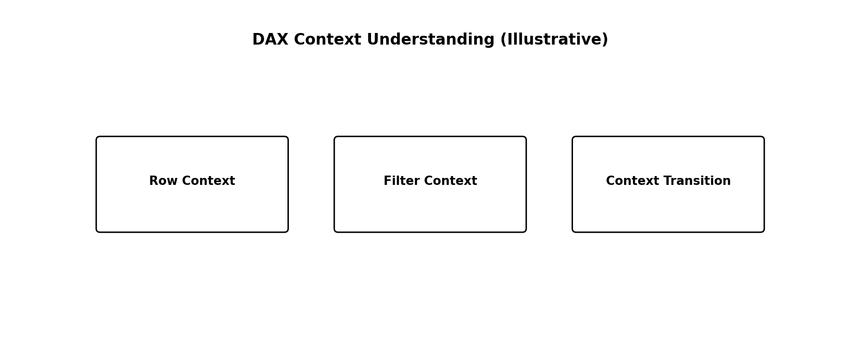
Figure 2: Core DAX context concepts used in Power BI
- Row Context – Exists when a formula is evaluated row by row, usually in calculated columns or iterators
- Filter Context – The set of filters applied by visuals, slicers, rows, columns, and page/report filters
- Context Transition – When row context is converted into filter context, usually by CALCULATE

10. Base Measures, Derived Measures, Composite Measures, and Final KPIs
A professional DAX workflow often follows a layered structure. First, simple base measures are created. Then derived or intermediate measures are built from them. After that, composite measures combine multiple measures or business rules. Finally, KPI measures are created for reporting.
Measure Type | Description | Example in Student Performance Dashboard
Base Measures | Basic calculations created directly from raw dataset columns without modification. | Average Math Score, Average Reading Score, Average Writing Score
Derived Measures | Measures calculated using one or more base measures to generate new insights. | Overall Average Score calculated from subject averages
Composite Measures | Measures formed by combining multiple calculations to provide deeper analysis. | Performance Percentage combining all subject scores
Final KPIs | Key performance indicators used to summarize important results for quick decision-making. | Total Students, Overall Performance %, Subject Average Score Cards

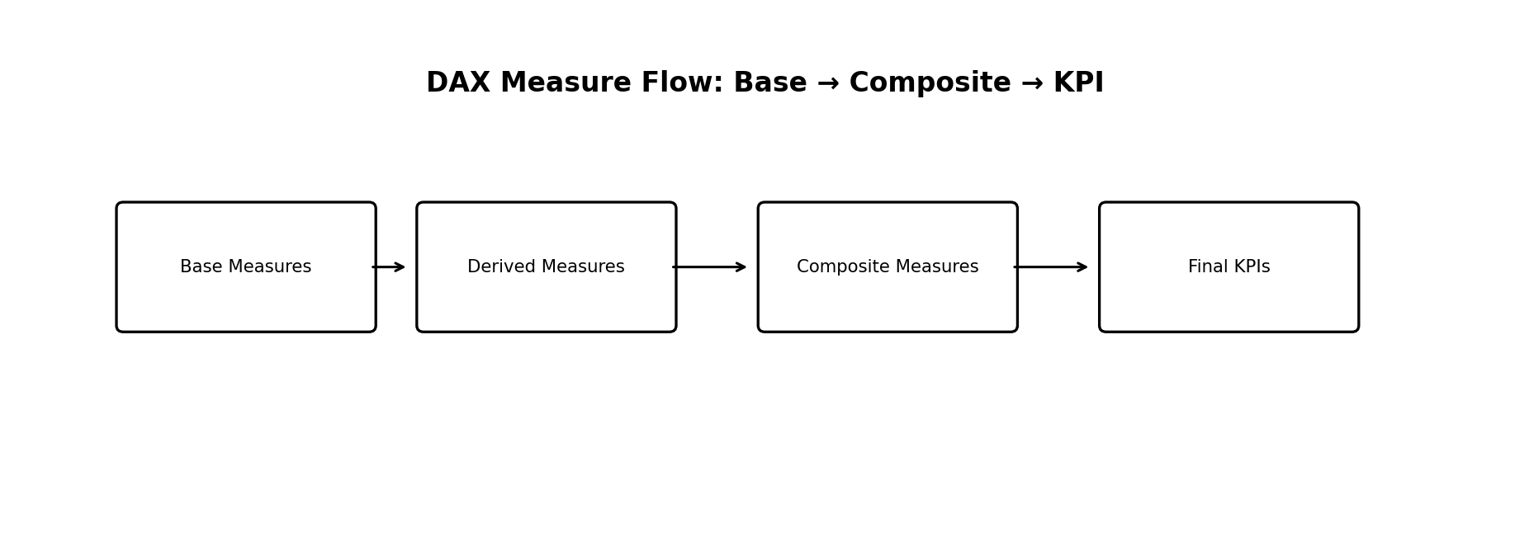
Figure 3: Professional DAX measure development flow

13. DAX Functions Most Useful for This Project
Function | Why Useful in This Dataset
COUNT / DISTINCTCOUNT | Count tickets and unique customers
AVERAGE | Average response, resolution, and satisfaction
CALCULATE | Apply business filters like Closed, Open, SLA Breached
DIVIDE | Safely calculate rates and percentages
IF / SWITCH | Create logical KPI categories or status buckets
FILTER | Create custom filtered calculations
SUMX / AVERAGEX | Advanced row-wise calculations when needed
ALL / ALLEXCEPT | Control filter behavior in comparisons
RELATED | Pull values across related tables if using star schema

14. Basic Practical on Dummy Dataset (Conceptual Example)
Before working on the main Student Performance Analysis project, a basic practical exercise was conducted using a dummy dataset to understand the workflow of data analytics in Power BI. The purpose of this practice was to gain hands-on experience with data loading, cleaning, transformation, and visualization techniques in a controlled environment.The dummy dataset helped in learning fundamental concepts without affecting the original project data.
Practical Activities Performed:
- Imported a sample dataset into Power BI.
- Explored dataset structure, columns, and data types.
- Performed basic data cleaning operations such as trimming extra spaces and replacing incorrect values.
- Applied simple transformations to prepare the data for analysis.
- Created basic visualizations like bar charts and KPI cards.
- Practiced filtering and slicer functionality.
- Understood relationships between columns.
- Learned how to create calculated measures for analysis.

Purpose of the Practical:
- The practical session helped in:
- Understanding the ETL process (Extract, Transform, Load).
- Building confidence in using Power BI tools.
- Learning visualization techniques before applying them to the real dataset.
- Reducing errors during the actual project implementation.

Outcome:
This initial practice provided a strong foundation for developing the Student Performance Analysis Dashboard by improving familiarity with Power BI features and analytical workflow.

15. Modeling Best Practices for Your Single-Table Dataset
- Start with a clean flat table, but split into dimensions if the project grows
- Always create a proper Date table for time intelligence
- Hide unnecessary technical columns from report view
- Use clear table and measure names
- Keep measures in a dedicated Measures table if possible
- Avoid many-to-many relationships unless absolutely required
- Prefer one-directional filtering unless business logic requires both directions
- Use star schema instead of over-normalized models for Power BI reporting

16. Common Modeling Mistakes to Avoid
- Keeping everything in one large flat table when the model becomes complex
- Creating ambiguous or bidirectional relationships unnecessarily
- Using calculated columns where a measure is better
- Not creating a Date table for date-based analysis
- Naming measures poorly or mixing business logic across visuals
- Ignoring cardinality and relationship direction

17. Week 6 Learning Summary
Week 6 focused on the theory and basic practical understanding of Power BI data modeling and DAX. The session explained why modeling is important, how a flat dataset can be transformed into a star schema, and how multiple tables can be created from a single source dataset for better analysis. It also introduced the core DAX concepts of measures, calculated columns, and calculated tables, along with the difference between base measures, derived measures, composite measures, and final KPI measures.
This week is a major milestone because it builds the analytical foundation required for advanced dashboards. A well-designed model and strong DAX measures make reports faster, more accurate, and more professional.

18. Conclusion
Week 6 introduced the core concepts that separate beginner-level Power BI reports from professional analytical solutions. By understanding data modeling, star schema design, relationship behavior, and DAX measure development, the project is now ready to move into advanced dashboard building. For the support ticket analytics project, modeling will help organize the current single-table dataset into a more scalable structure, while DAX will make it possible to create dynamic KPIs, operational metrics, and business-ready insights for decision-making.

